**DEPARTMENT OF COMPUTER SCIENCE AND ENGINEERING**

**20 Marks Non CIE Component**

**CS54: Java Programming TERM: Aug - Dec 2019**

**Title of the Project: Vehicle details database**

#### PROJECT TEAM MEMBERS

|  |  |  |  |
| --- | --- | --- | --- |
| **Sl. No** | **Semester Section** | **USN** | **Name** |
| 1 | V ‘A’ | 1MS17CS017 | ASHIKA SATISH |
| 2 | V ‘A’ | 1MS17CS032 | GARIMA MISHRA |
| 3 | V ‘A’ | 1MS17CS008 | AMBIKA G |

**INTRODUCTION**

What are Microservices?

Microservices is an approach to software architecture that builds a large, complex application from multiple small components that each perform a single function, such as authentication, notification, or payment processing. Each microservice is a distinct unit within the software development project, with its own codebase, infrastructure, and database. The microservices work together, communicating through web APIs or messaging queues to respond to incoming events.

Advantages of Microservices

* Developers have the freedom to independently deploy and develop services, resulting in faster decision making
* Due to their size and autonomy, a microservices based approach results in shorter development cycles, as different teams can be implementing different services simultaneously – dependency between teams is usually eliminated
* They can easily be deployed on containers, resulting in less overhead and portability across different environments
* Allows developers to embrace modern DevOps practices such as automated CI/CD pipelines as microservices integrates easily with CI/CD tools
* Easy to scale, as each service is usually elastic
* Microservices are easier to build, test and maintain
* Services are organized around business capabilities
* Empowers developers to adopt technology most suited for a specific service
* Better fault isolation: If one microservice fails, others will continue to function.

Disadvantages of MicroServices:

* A microservice architecture involves added complexity, as developers have to mitigate fault tolerance, reduce network latency, deal with varying programming languages, as well as load balancing across multiple services
* Testing microservices can be cumbersome and complicated, because of their distributed nature
* Increasing the number of microservices in an application increases the effort for effective integration and management
* Dealing with multiple databases can be painful

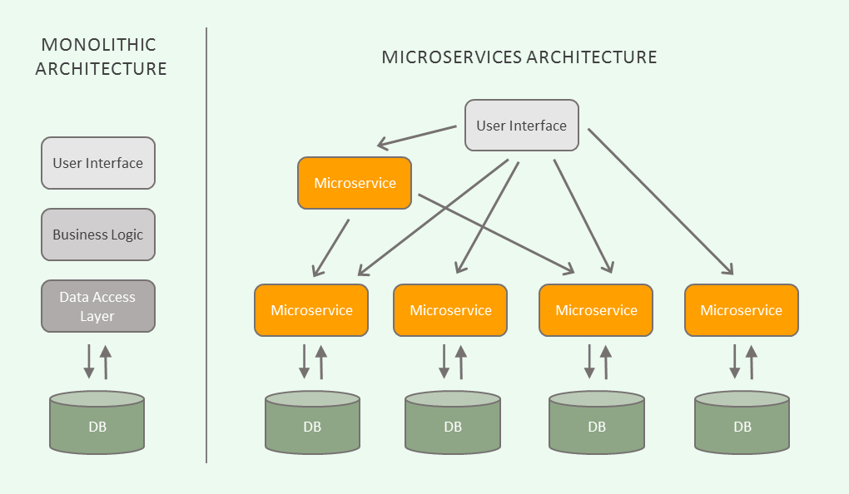

**PROBLEM STATEMENT**

To develop a RESTful API micro service for an employee database using Spring Boot and host the API on cloud foundry and also have a Web Application for the same. The micro service must provide appropriate API Endpoints to offer all the CRUD operation on the same database. Then the same API micro service must be hosted on cloud foundry and be functional.



**FUNCTIONAL REQUIREMENTS**

1. Spring Tool Suite

2. Latest version of Java Development Kit

3. SOAPUI

4. Cloud Foundry

5. XAMPP

    

**API FLOW CHART**

1. Create module

This module creates a vehicle table at the backend with attributes like vehicle number, state_code, RTO_code, RTO_count, Vehicle_type.If the table already exists then it simple drops it.

1. Insert module

This module accepts vehicle details such as like vehicle number,statuscode,RTOcode,RTOcount,Vehicletype and checks if these vehicle details already exist in the database. if yes it doesn’t add the record and gives an error otherwise it adds the vehicle details to the database and returns the same

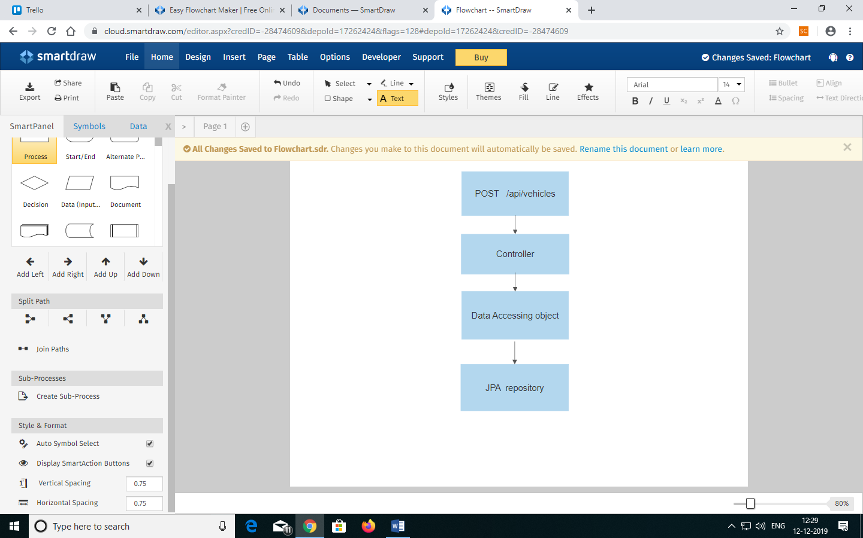

1. Retrieve module

This module retrieves all the vehicle details from the database by asking the user to enter RTOcode, RTOCount, StatusCode, Vnumber, Vtype and it displays them.

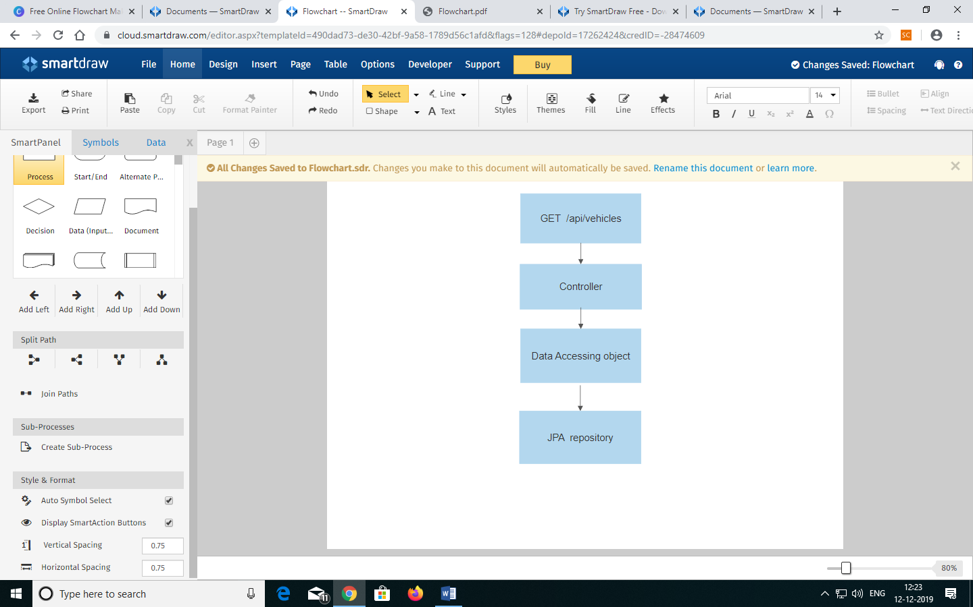

**IMPLEMENTATION DETAILS**

**Schema-mysql.sql**

DROP TABLE IF EXISTS vehicle;

CREATE TABLE vehicle (

Number VARCHAR(10) NOT NULL,

State_Code VARCHAR(2),

RTO_Code int,

RTO_Count int,

Vehicle_Type VARCHAR(255),

primary key (Number)

);

**VehicleController.java**

package com.javainuse.controllers;

import java.util.ArrayList;

import java.util.List;

import org.springframework.beans.factory.annotation.Autowired;

import org.springframework.stereotype.Controller;

import org.springframework.validation.Errors;

import org.springframework.web.bind.annotation.ModelAttribute;

import org.springframework.web.bind.annotation.RequestMapping;

import org.springframework.web.bind.annotation.RequestMethod;

import org.springframework.web.bind.annotation.RequestParam;

import org.springframework.web.servlet.ModelAndView;

import com.javainuse.model.Vehicle;

import com.javainuse.service.VehicleService;

@Controller

public class VehicleController {

@Autowired

VehicleService vehicleService;

@RequestMapping("/welcome")

public ModelAndView firstPage() {

return new ModelAndView("welcome");

}

@RequestMapping(value = "/addNewVehicle", method = RequestMethod.GET)

public ModelAndView show() {

return new ModelAndView("addVehicle", "v", new Vehicle());

}

@RequestMapping(value = "/addNewVehicle", method = RequestMethod.POST)

public ModelAndView processRequest(@ModelAttribute("v") Vehicle v) {

vehicleService.insertVehicle(v);

List

<Vehicle> vehicles = vehicleService.getAllVehicles();

ModelAndView model = new ModelAndView("getVehicles");

model.addObject("vehicles", vehicles);

return model;

}

@RequestMapping("/getVehicles")

public ModelAndView getVehicles() {

List

<Vehicle> vehicles = vehicleService.getAllVehicles();

ModelAndView model = new ModelAndView("getVehicles");

model.addObject("vehicles", vehicles);

return model;

}

**VehicleDaolmpl.java**

package com.javainuse.dao.impl;

import java.sql.PreparedStatement;

import java.sql.ResultSet;

import java.sql.SQLException;

import java.util.ArrayList;

import java.util.List;

import java.util.Map;

import javax.annotation.PostConstruct;

import javax.sql.DataSource;

import org.springframework.beans.factory.annotation.Autowired;

import org.springframework.jdbc.core.BatchPreparedStatementSetter;

import org.springframework.jdbc.core.RowMapper;

import org.springframework.jdbc.core.support.JdbcDaoSupport;

import org.springframework.stereotype.Repository;

import com.javainuse.dao.VehicleDao;

import com.javainuse.model.Vehicle;

@Repository

public class VehicleDaoImpl extends JdbcDaoSupport implements VehicleDao{

@Autowired

DataSource dataSource;

@PostConstruct

private void initialize(){

setDataSource(dataSource);

}

@Override

public void insertVehicle(Vehicle v) {

String sql = "INSERT INTO vehicle " + "(Number,State_Code,RTO_Code,RTO_Count, Vehicle_Type) VALUES (?, ?, ?, ?, ?)";

getJdbcTemplate().update(sql, new Object[]

{

v.getNumber(), v.getState_Code(), v.getRTO_Code(), v.getRTO_Count(), v.getVehicle_Type()

});

}

@Override

public void insertVehicles(final List

<Vehicle> vehicles) {

String sql = "INSERT INTO vehicle " + "(Number,State_Code,RTO_Code,RTO_Count, Vehicle_Type) VALUES (?, ?, ?, ?, ?)";

getJdbcTemplate().batchUpdate(sql, new BatchPreparedStatementSetter() {

public void setValues(PreparedStatement ps, int i) throws SQLException {

Vehicle vehicle = vehicles.get(i);

ps.setString(1, vehicle.getNumber());

ps.setString(2, vehicle.getState_Code());

ps.setInt(3, vehicle.getRTO_Code());

ps.setInt(4, vehicle.getRTO_Count());

ps.setString(5, vehicle.getVehicle_Type());

}

public int getBatchSize() {

return vehicles.size();

}

});

}

@Override

public List

<Vehicle> getAllVehicles(){

String sql = "SELECT * FROM vehicle";

List

<Map

<String, Object>> rows = getJdbcTemplate().queryForList(sql);

List

<Vehicle> result = new ArrayList

<Vehicle>();

for(Map

<String, Object> row:rows){

Vehicle v = new Vehicle();

v.setNumber((String)row.get("Number"));

v.setState_Code((String)row.get("State_Code"));

v.setRTO_Code((int)row.get("RTO_Code"));

v.setRTO_Count((int)row.get("RTO_Count"));

v.setVehicle_Type((String)row.get("Vehicle_Type"));

result.add(v);

}

return result;

}

@Override

public List

<Vehicle> getbyVNumber(String Number) {

// TODO Auto-generated method stub

return null;

}

@Override

public List

<Vehicle> getbyRTOCODE(String RTOCODE) {

// TODO Auto-generated method stub

return null;

}

@Override

public List

<Vehicle> getbyRTOCount(int RTOCount) {

// TODO Auto-generated method stub

return null;

}

**VehicleDao.java**

package com.javainuse.dao;

import java.util.List;

import com.javainuse.model.Vehicle;

public interface VehicleDao

{

void insertVehicle(Vehicle cus);

void insertVehicles(List<Vehicle> vehicles);

List<Vehicle> getAllVehicles();

List<Vehicle> getbyVNumber(String Number);

List<Vehicle> getbyRTOCODE(String RTOCODE);

List<Vehicle> getbyRTOCount(int RTOCount);

List<Vehicle> getbyStatusCode(String StatusCode);

List<Vehicle> getbyVType(String Type);

}

**Vehicle.java**

package com.javainuse.model;

public class Vehicle

{

private String Number;

private String State_Code;

private int RTO_Code;

private int RTO_Count;

private String Vehicle_Type;

public String getNumber() {

return Number;

}

public void setNumber(String Number) {

this.Number=Number;

}

public String getState_Code() {

return State_Code;

}

public void setState_Code(String State_Code) {

this.State_Code = State_Code;

}

public int getRTO_Code() {

return RTO_Code;

}

public void setRTO_Code(int RTO_Code) {

this.RTO_Code = RTO_Code;

}

public int getRTO_Count() {

return RTO_Count;

}

public void setRTO_Count(int RTO_Count) {

this.RTO_Count = RTO_Count;

}

public String getVehicle_Type() {

return Vehicle_Type;

}

public void setVehicle_Type(String Vehicle_Type) {

this.Vehicle_Type=Vehicle_Type;

}

@Override

public String toString() {

return "Vehicle [Number=" + Number + ", State Code=" + State_Code + ", RTO Code=" +RTO_Code + ", RTO Count=" + RTO_Count + ", Vehicle Type="+ Vehicle_Type + "]";

}

}

**VehicleServiceImpl.java**

package com.javainuse.service.impl;

import java.util.List;

import org.springframework.beans.factory.annotation.Autowired;

import org.springframework.stereotype.Service;

import com.javainuse.dao.VehicleDao;

import com.javainuse.model.Vehicle;

import com.javainuse.service.VehicleService;

@Service

public class VehicleServiceImpl implements VehicleService {

@Autowired

VehicleDao vehicleDao;

@Override

public void insertVehicle(Vehicle vehicle) {

vehicleDao.insertVehicle(vehicle);

}

@Override

public void insertVehicles(List<Vehicle> vehicles) {

vehicleDao.insertVehicles(vehicles);

}

@Override

public List<Vehicle> getAllVehicles() {

return vehicleDao.getAllVehicles();

}

@Override

public List<Vehicle> getbyVNumber(String Number)

{

return vehicleDao.getbyVNumber(Number);

}

@Override

public List<Vehicle> getbyVType(String Type)

{

return vehicleDao.getbyVType(Type);

}

@Override

public List<Vehicle> getbyRTOCODE(String RTOCODE)

{

return vehicleDao.getbyRTOCODE(RTOCODE);

}

@Override

public List<Vehicle> getbyRTOCount(int RTOCount)

{

return vehicleDao.getbyRTOCount(RTOCount);

}

@Override

public List<Vehicle> getbyStatusCode(String StatusCode)

{

return vehicleDao.getbyStatusCode(StatusCode);

}

}

**VehicleService.java**

package com.javainuse.service;

import java.util.List;

import com.javainuse.model.Vehicle;

public interface VehicleService {

void insertVehicle(Vehicle v);

void insertVehicles(List<Vehicle> vehicles);

List<Vehicle> getAllVehicles();

List<Vehicle> getbyVNumber(String Number);

List<Vehicle> getbyRTOCODE(String RTOCODE);

List<Vehicle> getbyRTOCount(int RTOCount);

List<Vehicle> getbyStatusCode(String StatusCode);

List<Vehicle> getbyVType(String Type);

}

**Add Vehicle Details - Frontend (addVehicle.jsp)**

<%@ taglib url="http://www.springframework.org/tags/form" prefix="form"%>

<html>

<head>

<meta http-equiv="Content-Type" content="text/html; charset=ISO-8859-1">

<title>Add Number Plate</title>

</head>

<jsp:include page="menu.jsp" />

<body>

<h3 style="color: red;">Add New Number Plate</h3>

<div id="addVehicle">

<form:form action="/addNewVehicle" method="post"

modelAttribute="v">

<p>

<label>Enter Vehicle Number</label>

<form:input path="Number" />

</p>

<p>

<label>Enter State Code</label>

<form:input path="State_Code" />

</p>

<p>

<label>Enter RTO Code</label>

<form:input path="RTO_Code" />

</p>

<p>

<label>Enter RTO Count</label>

<form:input path="RTO_Code" />

</p>

<p>

<label>Enter Vehicle Type</label>

<form:input path="Vehicle_Type" />

</p>

<input type="SUBMIT" value="Submit" />

</form:form>

</div>

</body>

</html>

**Welcome Page – Frontend (welcome.jsp)**

<%@page session="false"%>

<html>

<head>

<title>Welcome</title>

</head>

<body>

<jsp:include page="menu.jsp" />

<h3 style="color: red;">Hello Admin</h3>

</body>

</html>

**Menu Page – Frontend (menu.jsp)**

<%@taglib prefix="c" uri="http://java.sun.com/jsp/jstl/core"%>

<div style="border: 1px solid #ccc; padding: 5px; margin-bottom: 20px;">

<a href="${pageContext.request.contextPath}/welcome">Home</a> | &nbsp;

<a href="${pageContext.request.contextPath}/addNewVehicle">Add Number Plate</a> | &nbsp;

<a href="${pageContext.request.contextPath}/getbyVNumber">Search By Vehicle Number</a> | &nbsp;

<a href="${pageContext.request.contextPath}/getbyRTOCODE">Search By RTO Code</a> | &nbsp;

<a href="${pageContext.request.contextPath}/getbyRTOCount">Search By RTO Count</a> | &nbsp;

<a href="${pageContext.request.contextPath}/getbyVType">Search By Vehicle Type</a> | &nbsp;

<a href="${pageContext.request.contextPath}/getbyStatusCode">Search By Status Code</a> | &nbsp;

</div>

**Get Vehicle Details**

1. **getbyRTOCODE.jsp**

<%@taglib uri="http://www.springframework.org/tags/form" prefix="form"%>

<html>

<head>

<meta http-equiv="Content-Type" content="text/html; charset=ISO-8859-1">

<title>Search By RTOCODE</title>

</head>

<jsp:include page="menu.jsp" />

<body>

<h3 style="color: red;">RTOCODE Query</h3>

<div id="addVehicle">

<form action="/getbyRTOCODE" method="post">

<p>

<label>Display Vehicles by RTO CODE :</label>

<input type="text" name="RTOCODE" />

</p>

<input type="SUBMIT" value="Submit" />

</form>

</div>

</body>

</html>

1. **getbyRTOCount.jsp**

<%@taglib uri="http://www.springframework.org/tags/form" prefix="form"%>

<html>

<head>

<meta http-equiv="Content-Type" content="text/html; charset=ISO-8859-1">

<title>Search By RTO Count</title>

</head>

<jsp:include page="menu.jsp" />

<body>

<h3 style="color: red;">RTO Count Query</h3>

<div id="addVehicle">

<form action="/getbyRTOCount" method="post">

<p>

<label>Enter RTO Count</label>

<input type="text" name="RTOCount" />

</p>

<input type="SUBMIT" value="Submit" />

</form>

</div>

</body>

</html>

**3) getbyStatusCode.jsp**

<%@taglib uri="http://www.springframework.org/tags/form" prefix="form"%>

<html>

<head>

<meta charset="ISO-8859-1">

<title>Insert title here</title>

</head>

<jsp:include page="menu.jsp" />

<body>

<h3 style="color: red;">Query by Status Code</h3>

<div id="addTheatre">

<form action="/getbyStatusCode" method="post">

<p>

<label>Enter Status Code</label>

<input type="text" name="StatusCode" />

</p>

<input type="SUBMIT" value="Submit" />

</form>

</div>

</body></html>

**4) getbyVNumber.jsp**

<%@taglib uri="http://www.springframework.org/tags/form" prefix="form"%>

<html>

<head>

<meta charset="ISO-8859-1">

<title>Search by Vehicle Number </title>

</head>

<jsp:include page="menu.jsp" />

<body>

<h3 style="color: red;">Query by Vehicle Number</h3>

<div id="/addVehicle">

<form action="/getbyVNumber" method="post">

<p>

<label>Enter Vehicle Number</label>

<input type="text" name="VNumber" />

</p>

<input type="SUBMIT" value="Submit" />

</form>

</div>

</body>

</html>

**5) getbyVType.jsp**

<%@taglib uri="http://www.springframework.org/tags/form" prefix="form"%>

<html>

<head>

<meta http-equiv="Content-Type" content="text/html; charset=ISO-8859-1">

<title>Search By Vehicle Type</title>

</head>

<jsp:include page="menu.jsp" />

<body>

<h3 style="color: red;">Vehicle Type Query</h3>

<div id="addVehicle">

<form action="/getbyVType" method="post">

<p>

<label>Enter Vehicle Type</label>

<input type="text" name="VType" />

</p>

<input type="SUBMIT" value="Submit" />

</form>

</div>

</body>

</html>

**6) getVehicle.jsp**

<%@ taglib uri="http://java.sun.com/jsp/jstl/core" prefix="c"%>

<%@page session="false"%>

<html>

<head>

<title>Show Number Plates</title>

</head>

<body>

<jsp:include page="menu.jsp" />

<h3 style="color: red;">Show All Number Plates : </h3>

<ul>

<c:forEach var="listValue" items="${vehicle}">

<li>${listValue}</li>

</c:forEach>

</ul>

</body>

</html>

**Put Vehicle Details**

1. **putbyRTOCODE.jsp**

<%@ taglib uri="http://java.sun.com/jsp/jstl/core" prefix="c"%>

<%@page session="false"%>

<html>

<head>

<title>Show by RTO CODE</title>

</head>

<body>

<jsp:include page="menu.jsp" />

<h3 style="color: red;">The requested vehicles are :</h3>

<ul>

<c:forEach var="listValue" items="${vehicles}">

<li>${listValue}</li>

</c:forEach>

</ul>

</body>

</html>

**2) putbyRTOCount.jsp**

<%@ taglib uri="http://java.sun.com/jsp/jstl/core" prefix="c"%>

<%@page session="false"%>

<html>

<head>

<title>Show by RTO Count</title>

</head>

<body>

<jsp:include page="menu.jsp" />

<h3 style="color: red;">The requested vehicles are :</h3>

<ul>

<c:forEach var="listValue" items="${vehicless}">

<li>${listValue}</li>

</c:forEach>

</ul>

</body>

</html>

**3) putbyStatusCode.jsp**

<%@ taglib uri="http://java.sun.com/jsp/jstl/core" prefix="c"%>

<%@page session="false"%>

<html>

<head>

<meta charset="ISO-8859-1">

<title>Show by Status Code</title>

</head>

<body>

<jsp:include page="menu.jsp" />

<h3 style="color: red;">The requested vehicles are :</h3>

<ul>

<c:forEach var="listValue" items="${vehicles}">

<li>${listValue}</li>

</c:forEach>

</body>

</html>

**4) putbyVNumber.jsp**

<%@ taglib uri="http://java.sun.com/jsp/jstl/core" prefix="c"%>

<%@page session="false"%>

<html>

<head>

<meta charset="ISO-8859-1">

<title>Show by Vehicle Number</title>

</head>

<body>

<jsp:include page="menu.jsp" />

<h3 style="color: red;">The Vehicle with specified Vehicle Number is</h3>

<ul>

<c:forEach var="listValue" items="${vehicles}">

<li>${listValue}</li>

</c:forEach>

</ul>

</body>

</html>

**5) putbyVType.jsp**

<%@ taglib uri="http://java.sun.com/jsp/jstl/core" prefix="c"%>

<%@page session="false"%>

<html>

<head>

<title>Show by Vehicle Type</title>

</head>

<body>

<jsp:include page="menu.jsp" />

<h3 style="color: red;">The requested vehicles are :</h3>

<ul>

<c:forEach var="listValue" items="${vehicles}">

<li>${listValue}</li>

</c:forEach>

</ul>

</body>

</html>

**SCREEN SHOTS**

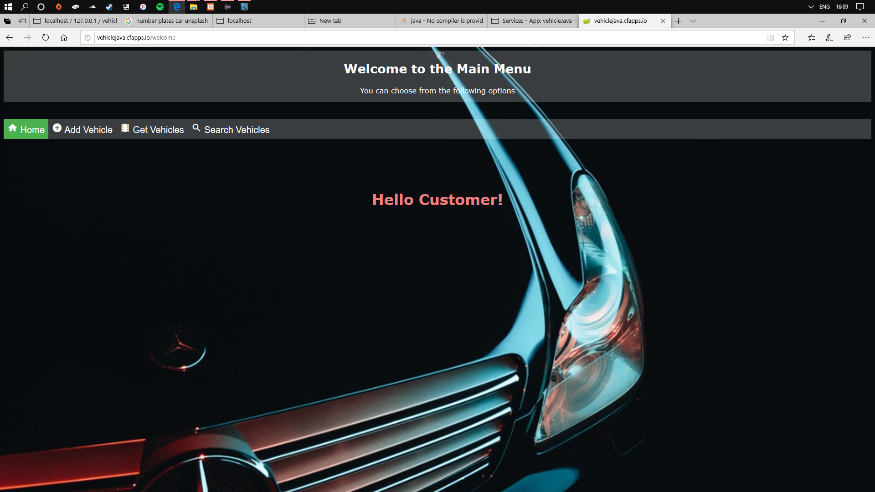

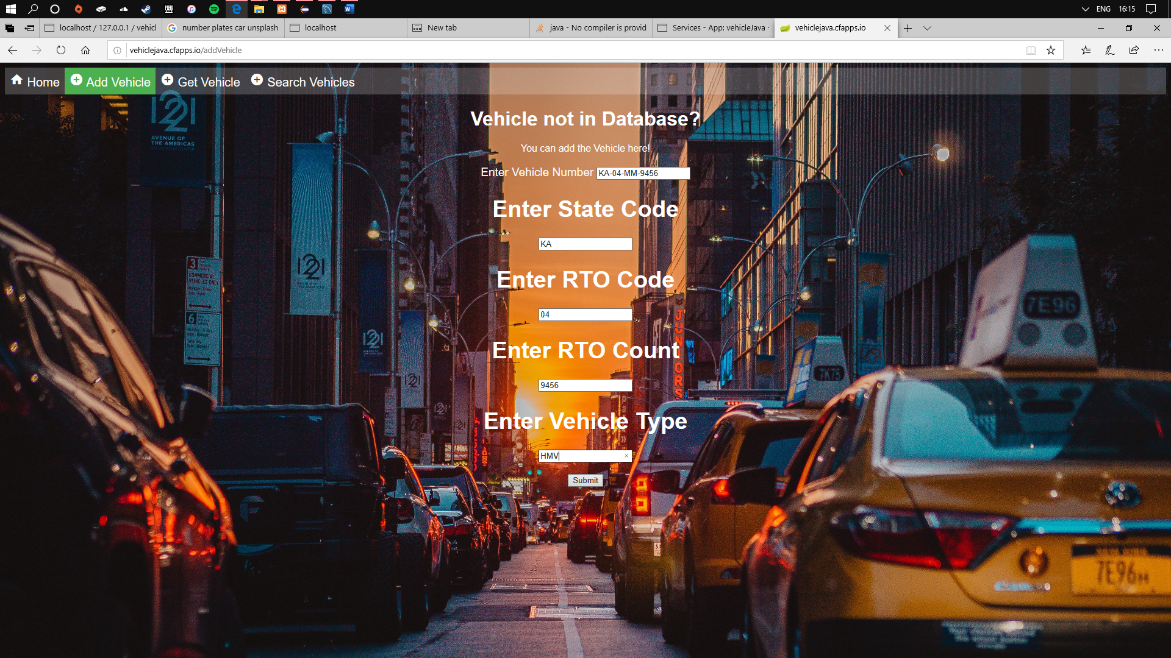

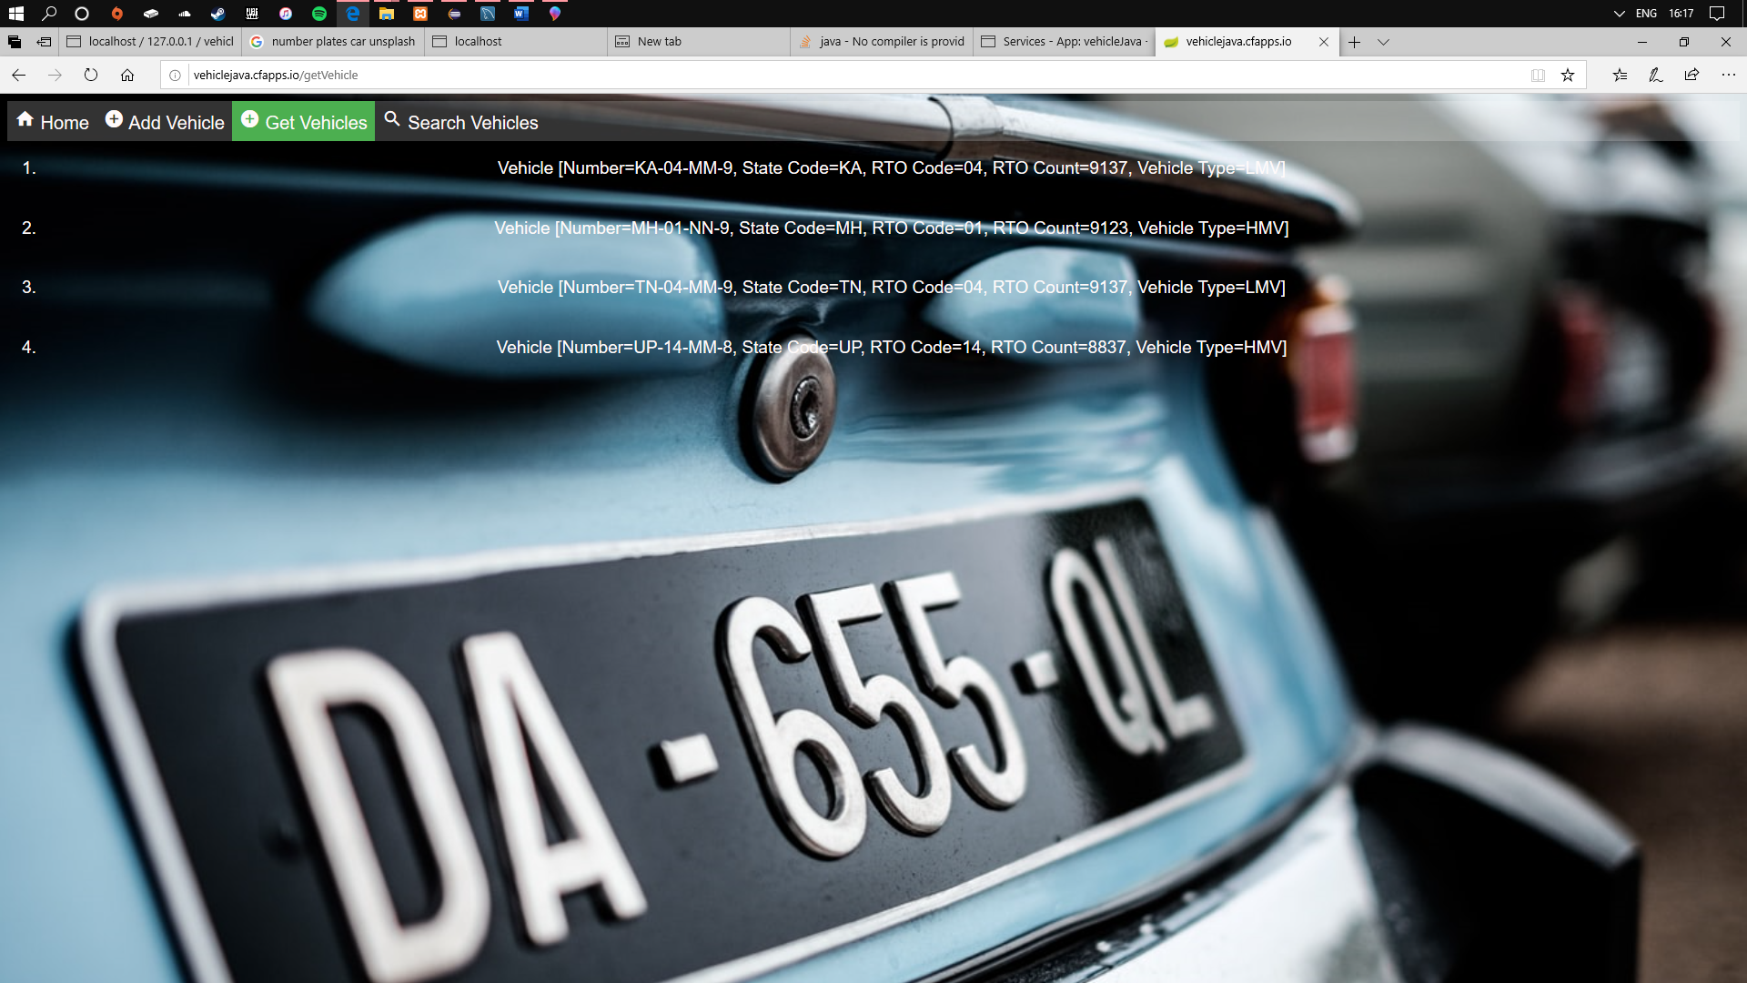

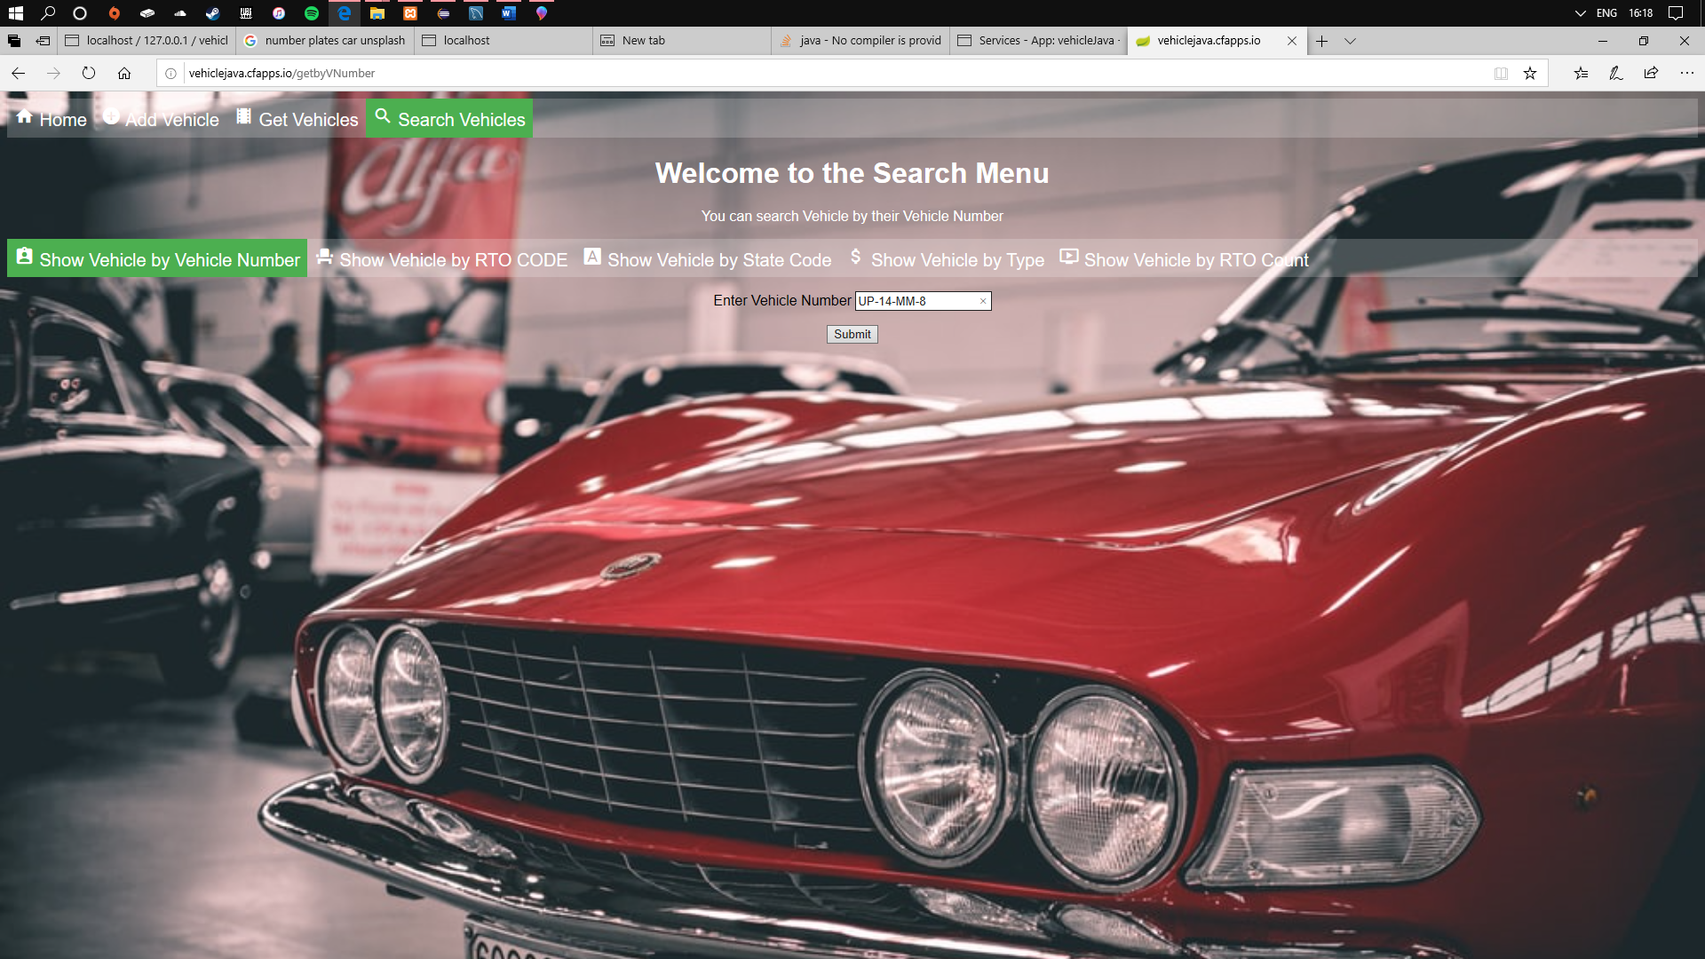

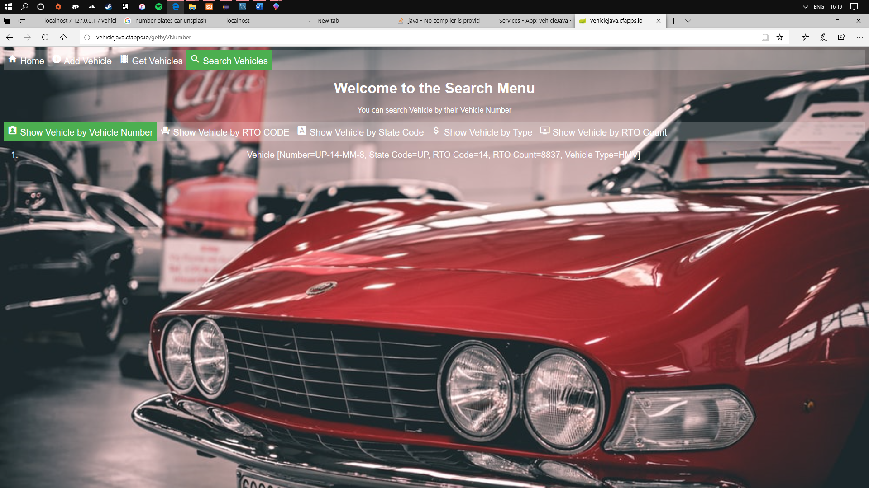

**READ ME**

• The Spring Boot Application connects to the MySQL server using JPA Repository.

• JPA Repository offers abstraction for updating, deleting , inserting object into the database. We

create a list of objects that gets updated in the database.

• The functions that can be used are: JPARepository.save() and JPARepository.get()

• This can be achieved by extending the repository to JPARepository class

• The RESTful API is done by receiving a set of requests and then send appropriate data back to the request.

• The API is then compiled into a JAR file using maven, which adds only the dependencies that are

used, and ignore the ones that are not specified.

• Since we have a MySQL Connection established, we need to provide the service in pivotal

dashboard.

• This is done by enabling ClearMySQL Database service by giving an appropriate Instance Name.

• The API is then hosted on Cloud Foundry by pushing the JAR file to the pivotal dashboard.